1. University Course Registration System
Aim
To design a relational database schema for a University Course Registration System by identifying entities, attributes, primary keys, foreign keys, and relationships between the tables.
Description
The University Course Registration System stores details of students, departments, faculty members, courses, and enrollments. The Enrollment table is used to establish a many-to-many relationship between students and courses. This design reduces redundancy and ensures efficient management of course registration.
Entities
- Student
- Department
- Course
- Faculty
- Enrollment
Attributes
Student
- StudentID
- Name
- DepartmentID
Department
- DepartmentID
- DepartmentName
Course
- CourseID
- CourseName
- FacultyID
Faculty
- FacultyID
- FacultyName
Enrollment
- StudentID
- CourseID
- Semester
Primary Keys
- StudentID
- DepartmentID
- CourseID
- FacultyID
Foreign Keys
- Student.DepartmentID → Department.DepartmentID
- Course.FacultyID → Faculty.FacultyID
- Enrollment.StudentID → Student.StudentID
- Enrollment.CourseID → Course.CourseID

Relationship Diagram
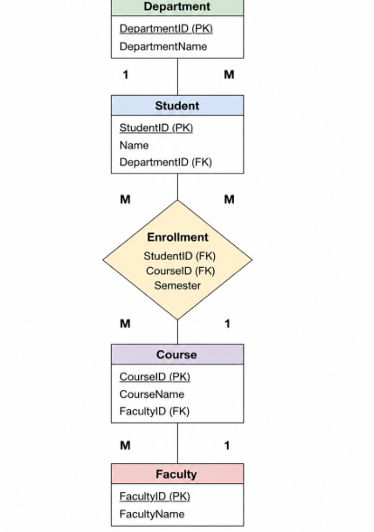
Relationship
- One Department can have many Students.
- One Faculty can teach many Courses.
- One Student can enroll in many Courses.
- One Course can have many Students.
- Student and Course have a Many-to-Many relationship through the Enrollment table.

Viva Questions
Q1. Why is the Enrollment table necessary instead of storing CourseID directly in the Student table?
Answer:
The Enrollment table is required because one student can enroll in many courses, and one course can have many students. It avoids data redundancy and properly represents the many-to-many relationship.
Q2. If the university wants to track grades for each enrolled course, how would you modify the schema?
Answer:
Add a new attribute Grade to the Enrollment table.
Modified Schema
Enrollment(StudentID, CourseID, Semester, Grade)
Result
Thus, the University Course Registration System database schema was successfully designed with appropriate entities, attributes, primary keys, foreign keys, and relationships.

2. Online Shopping System
Aim
To design a relational database schema for an Online Shopping System using entities, attributes, primary keys, foreign keys, and relationships.
Description
The Online Shopping System stores information about customers, products, orders, and order details. The OrderDetails table acts as a bridge table between the Order and Product tables, allowing multiple products to be included in a single order.
Entities
- Customer
- Product
- Order
- OrderDetails
Attributes
Customer
- CustomerID
- Name
Product
- ProductID
- ProductName
- Price
Order
- OrderID
- CustomerID
- OrderDate
OrderDetails
- OrderID
- ProductID
- Quantity
Primary Keys
- CustomerID
- ProductID
- OrderID
Foreign Keys
- Order.CustomerID → Customer.CustomerID
- OrderDetails.OrderID → Order.OrderID
- OrderDetails.ProductID → Product.ProductID
Relationship Diagram
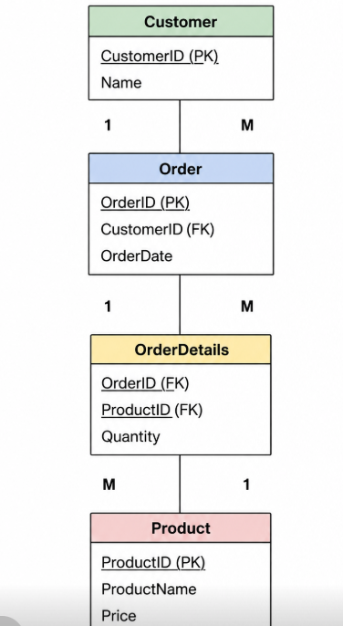
Relationship
- One Customer can place many Orders.
- One Order can contain many Products.
- One Product can appear in many Orders.
- Order and Product have a Many-to-Many relationship through the OrderDetails table.
Viva Questions
Q1. Why is the OrderDetails table required in this schema?
Answer:
The OrderDetails table stores the products and their quantities for each order. It acts as a bridge table between Order and Product and supports the many-to-many relationship.
Q2. What would happen if ProductID were stored directly in the Order table?
Answer:
Each order would contain only one product. To store multiple products, duplicate order records would be required, leading to redundancy and update anomalies.
Result
Thus, the Online Shopping System database schema was successfully designed with suitable entities, attributes, keys, and relationships.

3. Library Management System
Aim
To design a relational database schema for a Library Management System by identifying entities, attributes, primary keys, foreign keys, and relationships.
Description
The Library Management System maintains information about members, books, and book issue transactions. The Issue table connects the Member and Book tables and records borrowing details such as issue date and return date.
Entities
- Member
- Book
- Issue
Member
- MemberID
- Name
Book
- BookID
- Title
- Author
Issue
- MemberID
- BookID
- IssueDate
- ReturnDate
Primary Keys
- MemberID
- BookID
Foreign Keys
- Issue.MemberID → Member.MemberID
- Issue.BookID → Book.BookID
Relationship Diagram
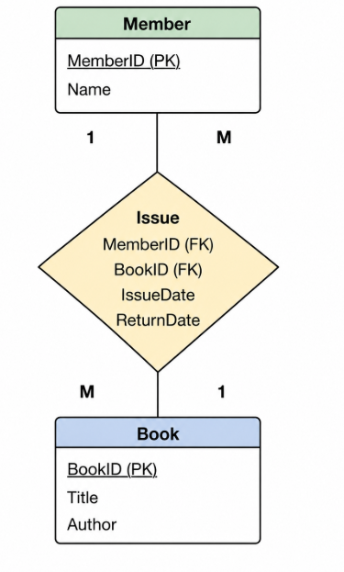
Relationship
- One Member can borrow many Books.
- One Book can be borrowed by many Members over time.
- Member and Book have a Many-to-Many relationship through the Issue table.

Viva Questions
Q1. Explain the relationship between Member and Book through the Issue table.
Answer:
A member can borrow multiple books, and a book can be borrowed by different members at different times. The Issue table stores borrowing details and connects the Member and Book tables.
Q2. How would you modify the schema to track overdue fines?
Answer:
Add a new attribute FineAmount to the Issue table.
Modified Schema
Issue(MemberID, BookID, IssueDate, ReturnDate, FineAmount)
Result
Thus, the Library Management System database schema was successfully designed with appropriate entities, attributes, primary keys, foreign keys, and relationships.
These three sections are based on the content of your uploaded document and are ready to copy into your practical record.

